**C++ Programming**

Lab Manual # 2

Name : Hussain Aun Ali

CMS : 463652

Section – A

Q1) Calculating student’s grade based on their score

#include <iostream>

using namespace std;

int main(){

float score;

cout<<"Enter your score: "<<endl; //taking score as input

cin>>score;

if (90<=score && score<=100){ //checking required condition

cout<<"Grade: A"<<endl;

}

else if (75<=score && score<90){

cout<<"Grade: B"<<endl;

}

else if (60<=score && score<75){

cout<<"Grade: C"<<endl;

}

else if (45<=score && score<60){

cout<<"Grade: D"<<endl;

}

else if (0<=score && score<45){

cout<<"Grade: F"<<endl;

}

else{

cout<<"Invalid Syntax"<<endl; //this outputs if score is out of valid

}

**Output:**

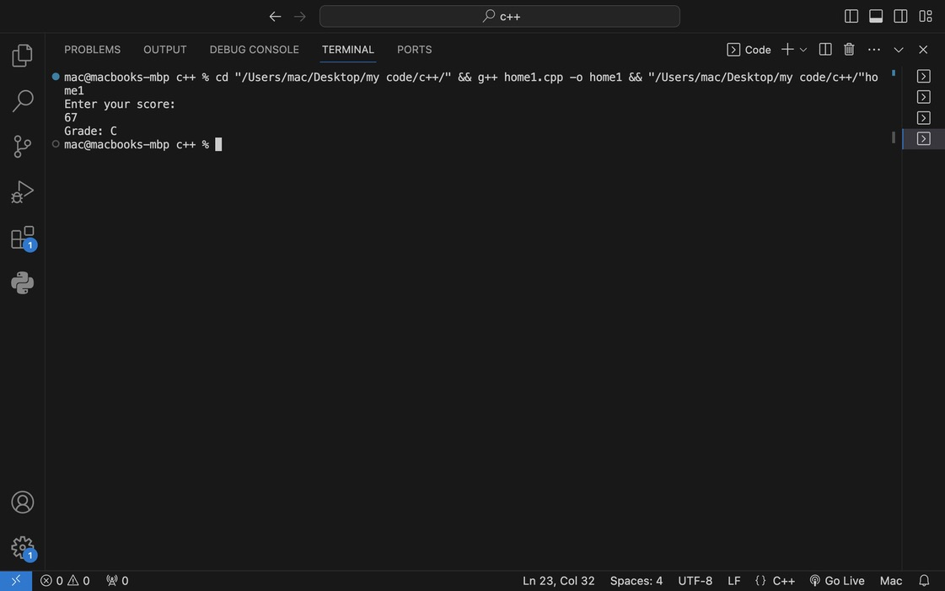

Q2) Taking an integer as input and checking its divisibility by 5 & 2.

int number;

cout<<"Enter an integer: "<<endl; //taking integer as input

cin>>number;

if (number%2==0 && number%5==0){ //number divisible by 5 & 2

cout<<"Number is even and divisible by 5"<<endl;

}

else if(number%2==0 && number%5!=0){ //number divisible by 2 but not 5

cout<<"Number is even but not divisible by 5"<<endl;

}

else if (number%2!=0 && number%5==0){ //number divisible by 5 but not 2

cout<<"Number is divisible by 5 but not even"<<endl;

}

else{ //number not divisible by 5 or 2

cout<<"Number is neither even nor divisible by 5"<<endl;

}

**Output:**

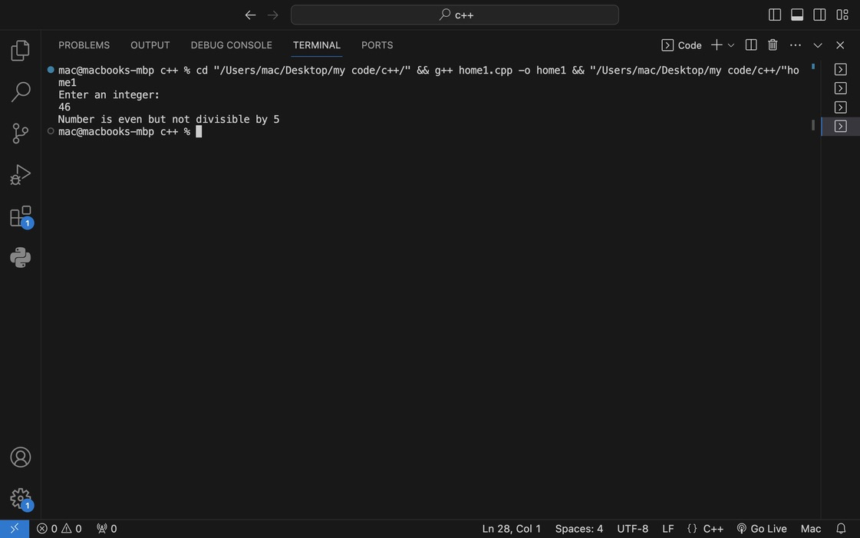

Q3) Checking whether an entered year is a leap year or not

//A Year is a leap year if it is completely divisible by 4 but not by 100

int year;

cout<<"Enter a year: "<<endl; //taking user input

cin>>year;

if (year%4==0 && year%100!=0){ //checking the required condition

cout<<"Year is a leap year"<<endl;

}

else{

cout<<"Year is NOT a leap year"<<endl;

}

**Output:**

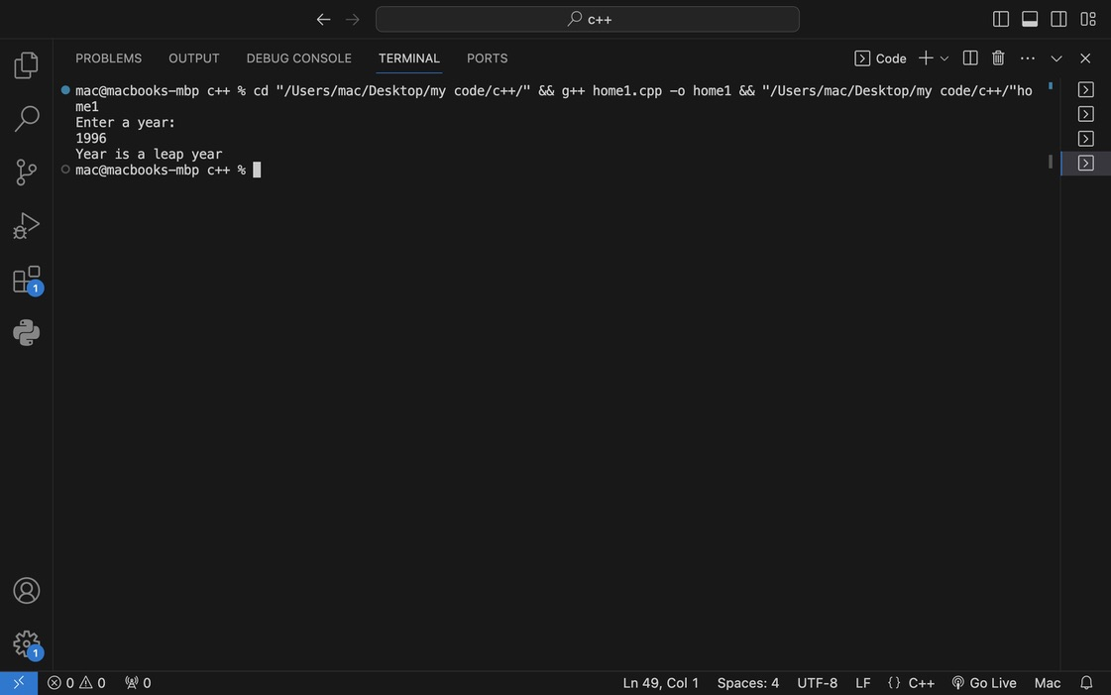

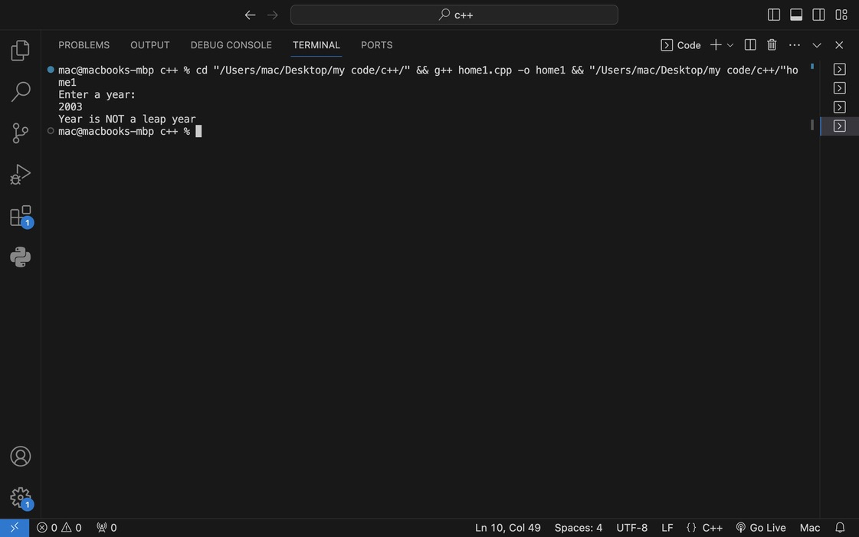

Q4) Checking eligibility of scholarship

float gpa;

int classes;

cout<<"Enter your GPA: "<<endl;

cin>>gpa;

cout<<"Enter the number of classes attended\nTotal no. of classes are 50: "<<endl;

cin>>classes;

bool condition = gpa<=4 && classes<=50; /*checks if GPA and classes are in valid range for program to proceed*/

if (condition){

double percent_classes = (classes / 50.0) * 100.0; //calculating atendance %

if (gpa>=3.5 && percent_classes>=80){

cout<<"You are eligible for Scholarship"<<endl;

}

else{

cout<<"Not eligible for Scholarship"<<endl;

}

}

else{

cout<<"Invalid Syntax"<<endl; /*this message outputs if GPA and classes not in valid range*/

}

**Output:**

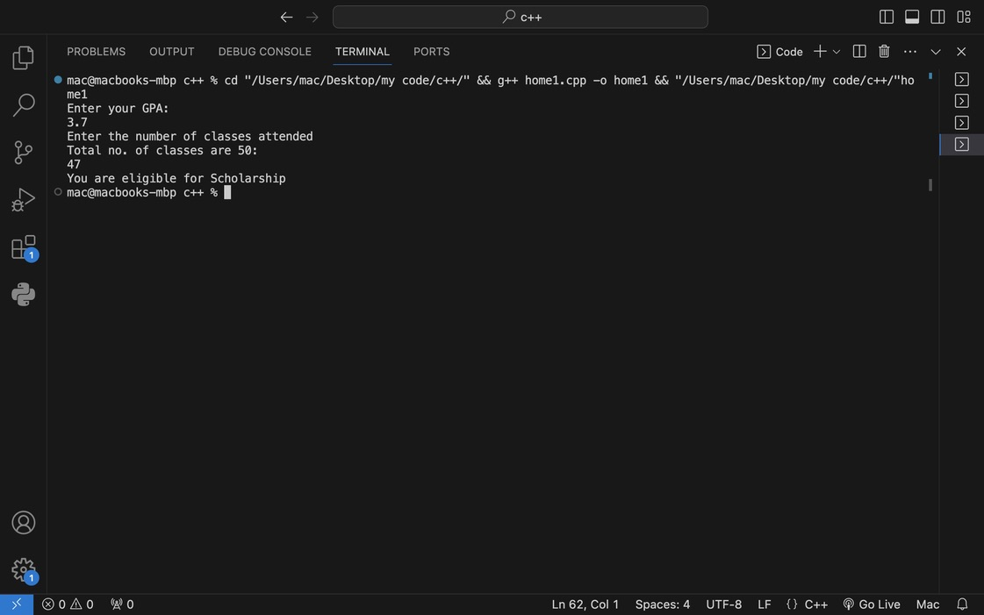

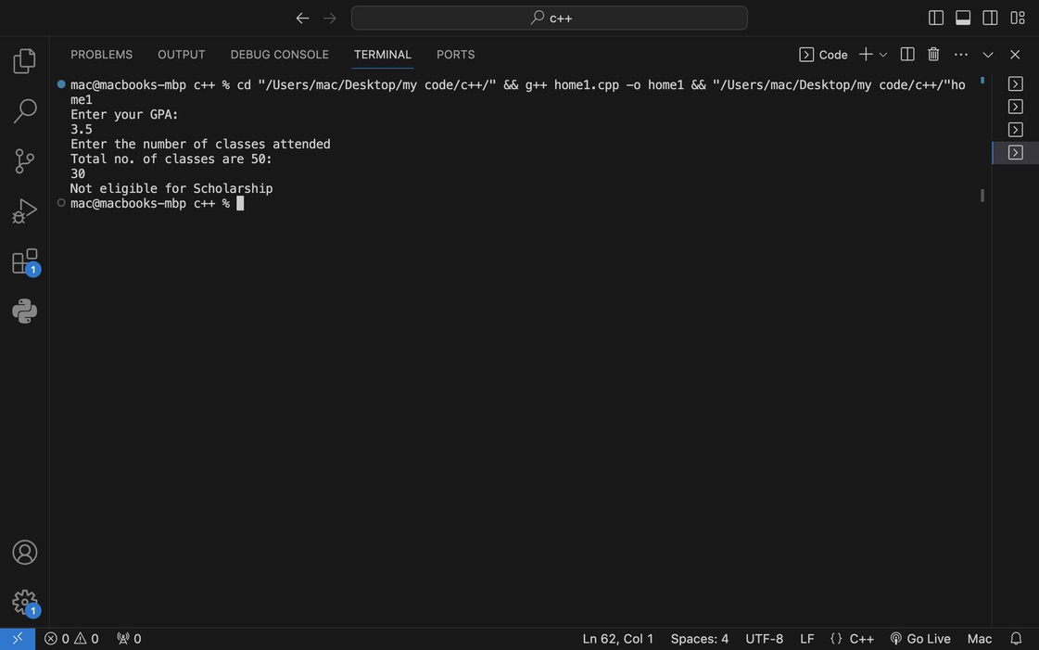

Q5) Checking if given input is a consonant or a variable

char character;

cout<<"Enter a character: "<<endl;

cin>>character;

character = tolower(character); /*converting to lowercase to fail proof program if a corresponding alphabet is entered in uppercase*/

if (character=='a' || character=='e' || character=='i' || character=='o' || character=='u'){

cout<<"Character is a vowel"<<endl;

}

else{

cout<<"Character is a consonant"<<endl;

}

}

**Output:**

